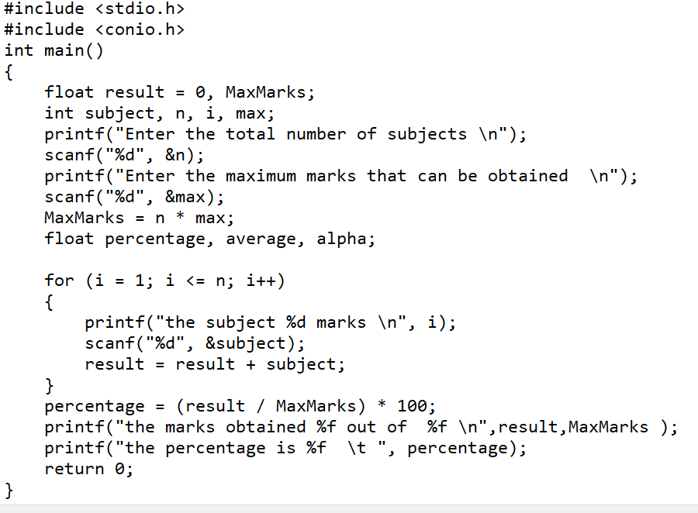Program 1 :WAP that accepts the marks of 5 subjects and finds the sum and percentage marks obtained by the student.

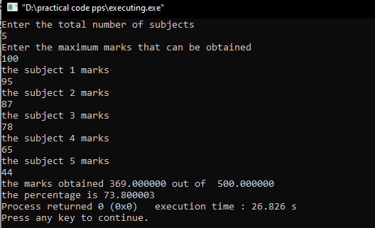Output:

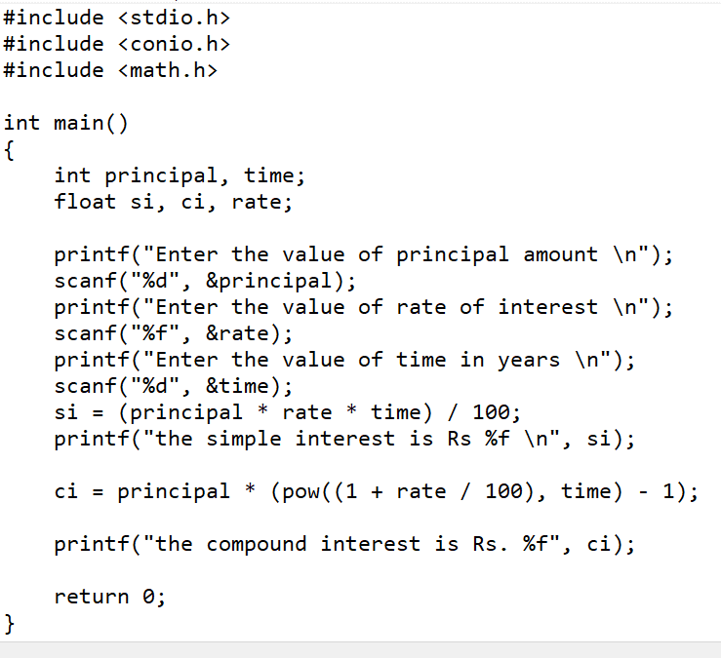Program 2: WAP that calculates the Simple Interest and Compound Interest. The Principal, Amount, Rate of Interest and Time are entered through the keyboard.

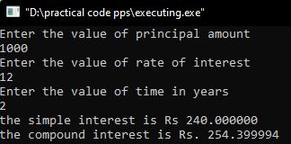

Output:

Program 3: WAP that swaps values of two variables using a third variable.

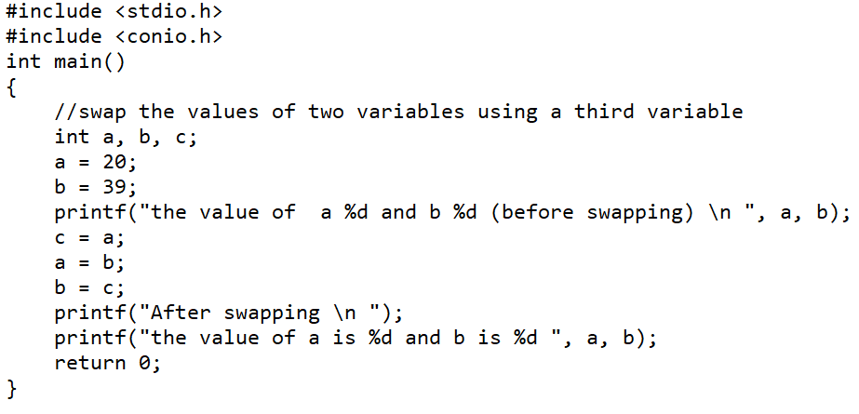

Output:

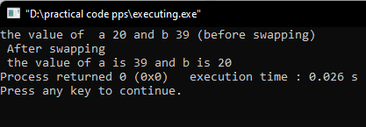

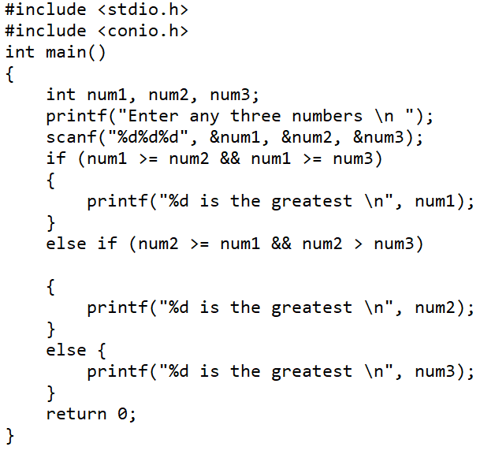Program 4 : WAP to find the greatest of three numbers

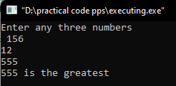 Output:

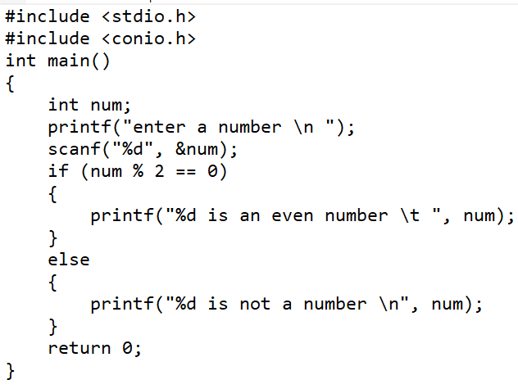Program 5 : WAP that finds whether a given number is even or odd.

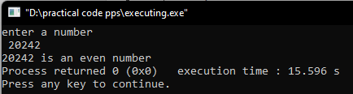Output:

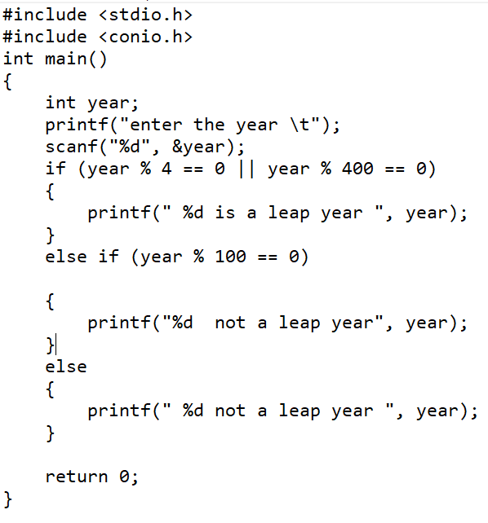Program 6: WAP that tells whether a given year is a leap year or not.



Output:

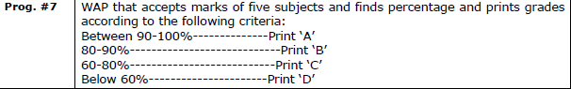

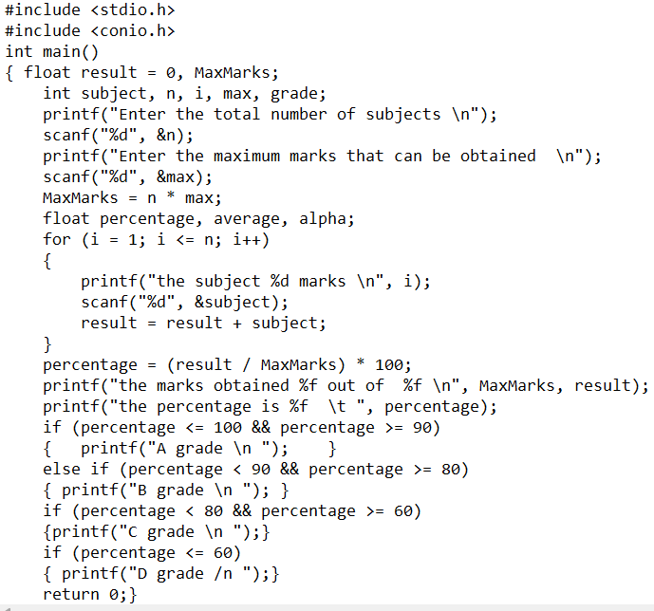

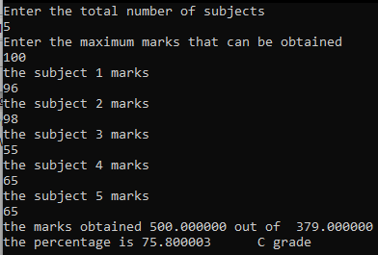

output:

Program 8:

|  |
| --- |
| WAP that takes two operands and one operator from the user to design a simple calculator with four basic operations (+,-,*,and /) and prints the result by using Switch statement. |

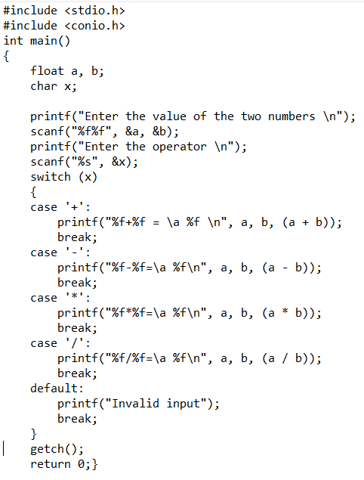

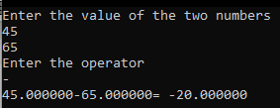

Output :